**Brain Builder – Autumn 1**

Over the next couple of weeks your task is to create a fact file about a **hot** or **cold** place in your Brain Builder book (A4 size). You can use pens, pencils, or paints to create your fact file, the choice is yours. Your fact file could include the follow:

* Types of wildlife
* Types of plants
* Climate
* Physical features – naturally made
* Human features – human made 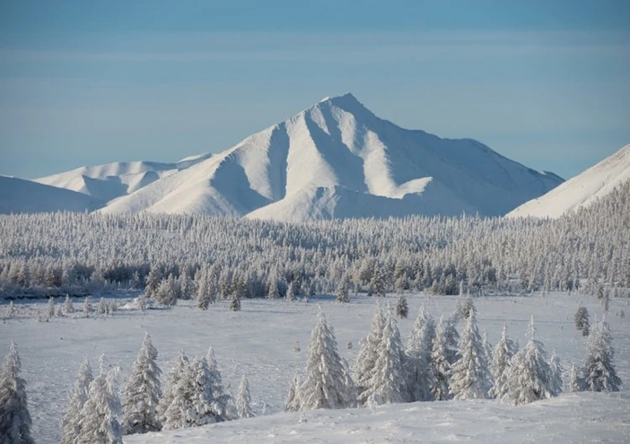

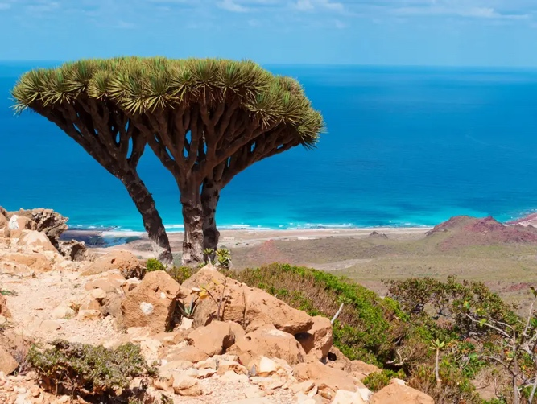

**Your Brain Builder is due on: _10th October 2024**

**Brain Builder – Autumn 1**

Over the next couple of weeks your task is to create a fact file about a **hot** or **cold** place in your Brain Builder book (A4 size). You can use pens, pencils, or paints to create your fact file, the choice is yours. Your fact file could include the follow:

* Types of wildlife
* Types of plants
* Climate
* Physical features – naturally made
* Human features – human made 



**Your Brain Builder is due on: _10th October 2024**