Sent out: Thursday 25th April | Due back: Thursday 16th May
Task:
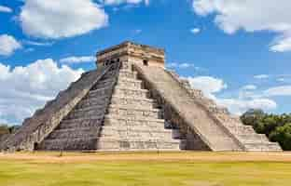 The Mayan civilisation

Do some research about the ancient Mayan civilisation. You could do this as a broad overview or as a focused project looking at one aspect of the Mayans such as: what did they believe in, how did they live or why was their civilisation so important.

As always, you can present this learning in any way that you like. Some ideas include: a double page spread, a poster, an informative piece of writing, a small model or a piece of artwork.

A reminder that your brain builder should not take more than a double page in your book.

Sent out: Thursday 25th April | Due back: Thursday 16th May
Task:
The Mayan civilisation

Do some research about the ancient Mayan civilisation. You could do this as a broad overview or as a focused project looking at one aspect of the Mayans such as: what did they believe in, how did they live or why was their civilisation so important.

As always, you can present this learning in any way that you like. Some ideas include: a double page spread, a poster, an informative piece of writing, a small model or a piece of artwork.

A reminder that your brain builder should not take more than a double page in your book.

