Sent out: Thursday 14th November | Due back: Thursday 5th December
Task:
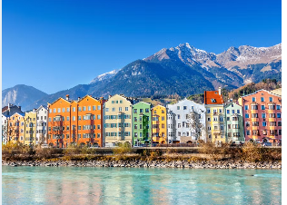What is life like in the Alps?

Do some research about the Alps. You could do this as a broad overview or as a focused project looking at one aspect of the Alps such as: what makes the Alps special; what is it like to live in the Alps; what wildlife is there is in the Alps; why people like to visit the Alps.

As always, you can present this learning in any way that you like. Some ideas include: a double page spread, a poster, an informative piece of writing, writing from the point of view of someone who visits the Alps such as a diary, a small model or a piece of artwork.

A reminder that your brain builder should not take more than a double page in your book.

Sent out: Thursday 14th November | Due back: Thursday 5th December
Task:
What is life like in the Alps?

Do some research about the Alps. You could do this as a broad overview or as a focused project looking at one aspect of the Alps such as: what makes the Alps special; what is it like to live in the Alps; what wildlife is there is in the Alps; why people like to visit the Alps.

As always, you can present this learning in any way that you like. Some ideas include: a double page spread, a poster, an informative piece of writing, writing from the point of view of someone who visits the Alps such as a diary, a small model or a piece of artwork.

A reminder that your brain builder should not take more than a double page in your book.

