Sent out: Thursday 19th September | Due back: Thursday 10th October
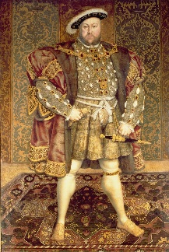Task: What was life like in Tudor England?

Do some research about life in Tudor England. You could do this as a broad overview or as a focused project looking at one aspect of Tudor life such as: Henry VII and the Battle of Bosworth, Henry VIII and his wives, Mary I, Elizabeth I, the Mary Rose, Shakespeare. Or, you could base it on our learning at Hampton Court Palace.

As always, you can present this learning in any way that you like. Some ideas include: a double page spread, a poster, an informative piece of writing, writing from the point of view of a Tudor such as a diary, a small model or a piece of artwork.

A reminder that your brain builder should not take more than a double page in your book.

Sent out: Thursday 19th September | Due back: Thursday 10th October
Task: What was life like in Tudor England?

Do some research about life in Tudor England. You could do this as a broad overview or as a focused project looking at one aspect of Tudor life such as: Henry VII and the Battle of Bosworth, Henry VIII and his wives, Mary I, Elizabeth I, the Mary Rose, Shakespeare. Or, you could base it on our learning at Hampton Court Palace.

As always, you can present this learning in any way that you like. Some ideas include: a double page spread, a poster, an informative piece of writing, writing from the point of view of a Tudor such as a diary, a small model or a piece of artwork.

A reminder that your brain builder should not take more than a double page in your book.

